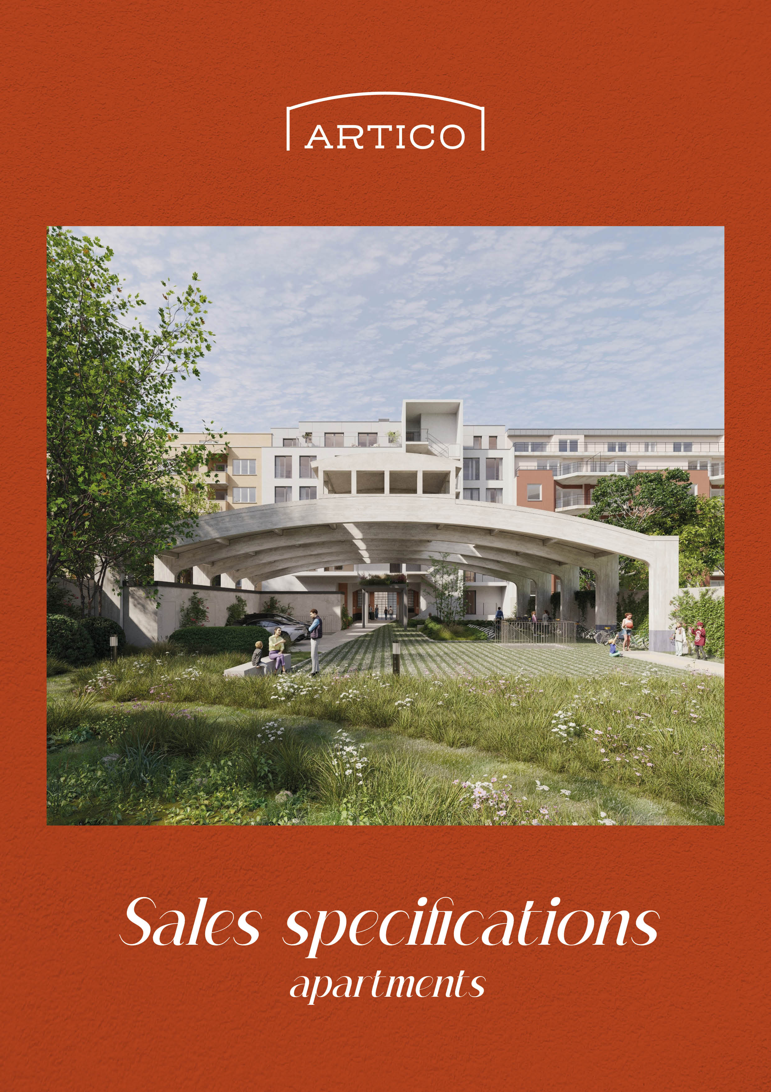
PARTNERS

Developer
ALIDES
Foreestelaan 86/201
9000 Gent


Architect
LD2 architecture
Terhulpsesteenweg 117/17
1170 Brussels


Stability
VK Architects & Engineers, part of Sweco
Brugsesteenweg 210
8800 Roeselare


Technics & PEB reporting
Studiebureau Van Reeth
Satenrozen 1A bus 3
2550 Kontich


Acoustics
D2S International
Ambachtenlaan 54
3001 Leuven


Safety coordinator
Climatex
Mieregemstraat 30/10
1785 Merchtem

Notary
Bernard Sacré
Kapitein Crespelstraat 16
1050 Ixelles (Brussels)

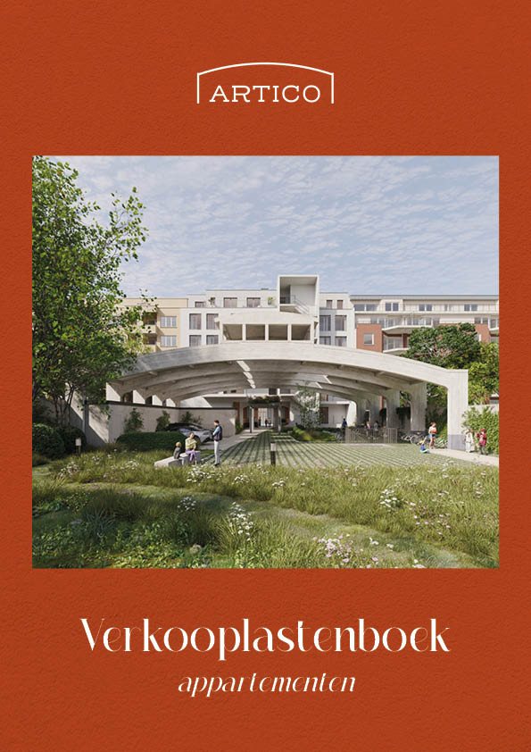
General Contractor
To be determined

Customer support
To be determined

CONTENT
1 The project 7
2 Description of the general construction works 9
2.1 Structural work 9
2.1.1 Groundworks 9
2.1.2 Foundations 9
2.1.3 Load-bearing construction 9
2.1.4 Walls 9
2.1.5 Floors 10
2.1.6 Façades 10
2.1.7 Roofstructure 10
2.1.8 Exterior carpentry 11
2.2 Thermal and acoustic insulation 12
2.3 Technical pipes 12
2.3.1 Technical shafts 12
2.3.2 Water supply and drainage 13
2.3.3 Recycling of rainwater 13
2.3.4 Sewage system 13
2.4 Fire safety 13
2.5 Utilities 13
2.5.1 Water en electricity 13
2.5.2 Tele distribution, internet- and telephone connections 13
2.5.3 Connection of utilities 13
3 Finishing of the private areas 15
3.1 Floors and skirting boards 15
3.1.1 Tiles 15
3.1.2 Parquet 15
3.1.3 Skirting boards 15
3.2 Walls and ceilings 16
3.2.1 Wall tiles 16
3.2.2 Suspended ceilings 16
3.2.3 Plaster 16
3.3 Interior joinery and accessories 16
3.3.1 Entrance door apartment 16
3.3.2 Internal doors 16
3.3.3 Window sills 16
3.3.4 Letterbox, videophone and door opener 17
3.4 Kitchen 17
3.5 Bathroom and sanitary appliances 17
3.6 Electricity 18
3.6.1 Basic setup 18
PV-Panels 20
3.7 Heating 20
3.8 Sanitary installation 21
3.9 Ventilation 21
3.10 Underground car park (if applicable) 22
3.11 Above-ground car park (if applicable) 22
3.12 Basement storerooms (if applicable) 23
3.13 Above-ground storerooms (if applicable) 23
4 Finishing of the common areas 24
4.1 Floors and skirting boards 24
4.2 Walls and ceilings 24
4.2.1 Plaster 24
4.2.2 Paintwork 24
4.3 Internal doors 24
4.4 Electricity 25
4.5 Heating 25
4.6 Lift installation 25
4.7 Fire protection 25
4.8 Access Control 26
4.9 Bicycle park 26
5 CHOISES AND CHANGES 27
5.1 Choice of finishing 27
5.2 Timetable of decisions 27
5.3 Changes at the request of the Purchaser 27
5.4 Additional works and reduction 28
5.4.1 Additional works 28
5.4.2 Reduction in work 28
5.5 Changes by the Vendor 28
5.6 Works performed by the Purchaser 29
6 Administrative stipulations 30
6.1 General 30
6.2 Floor area and dimensions of the property 30
6.2.1 Gros (floor)area 30
6.2.2 General disclaimer 30
6.2.3 Price of the property 31
6.3 STIPULATIONS 31
6.4 Indications on plan and images 31
6.5 Access to the site 31
6.6 Fees designer and engineering bureaus 32
6.7 Remarks 32
6.8 Insurances and transfer of risks 32
6.9 Conclusion 32

THE project
Welcome to the cosiest neighbourhood of Evere!

Located close to bustling Brussels and the centre of Europe, near the beating heart of our capital where NATO, Brussels Airport and many multinationals have their headquarters. Where bustle and tranquillity meet, there you will find Artico.
A new construction project full of character with 21 spacious units, from studios to 1-, 2- or 3-bedroom apartments, each with large windows and spacious terraces. Perfect as a home, a hub or a smart investment.
.
Welcome at Artico!
Welcome in the cosiest neighbourhood of Evere!
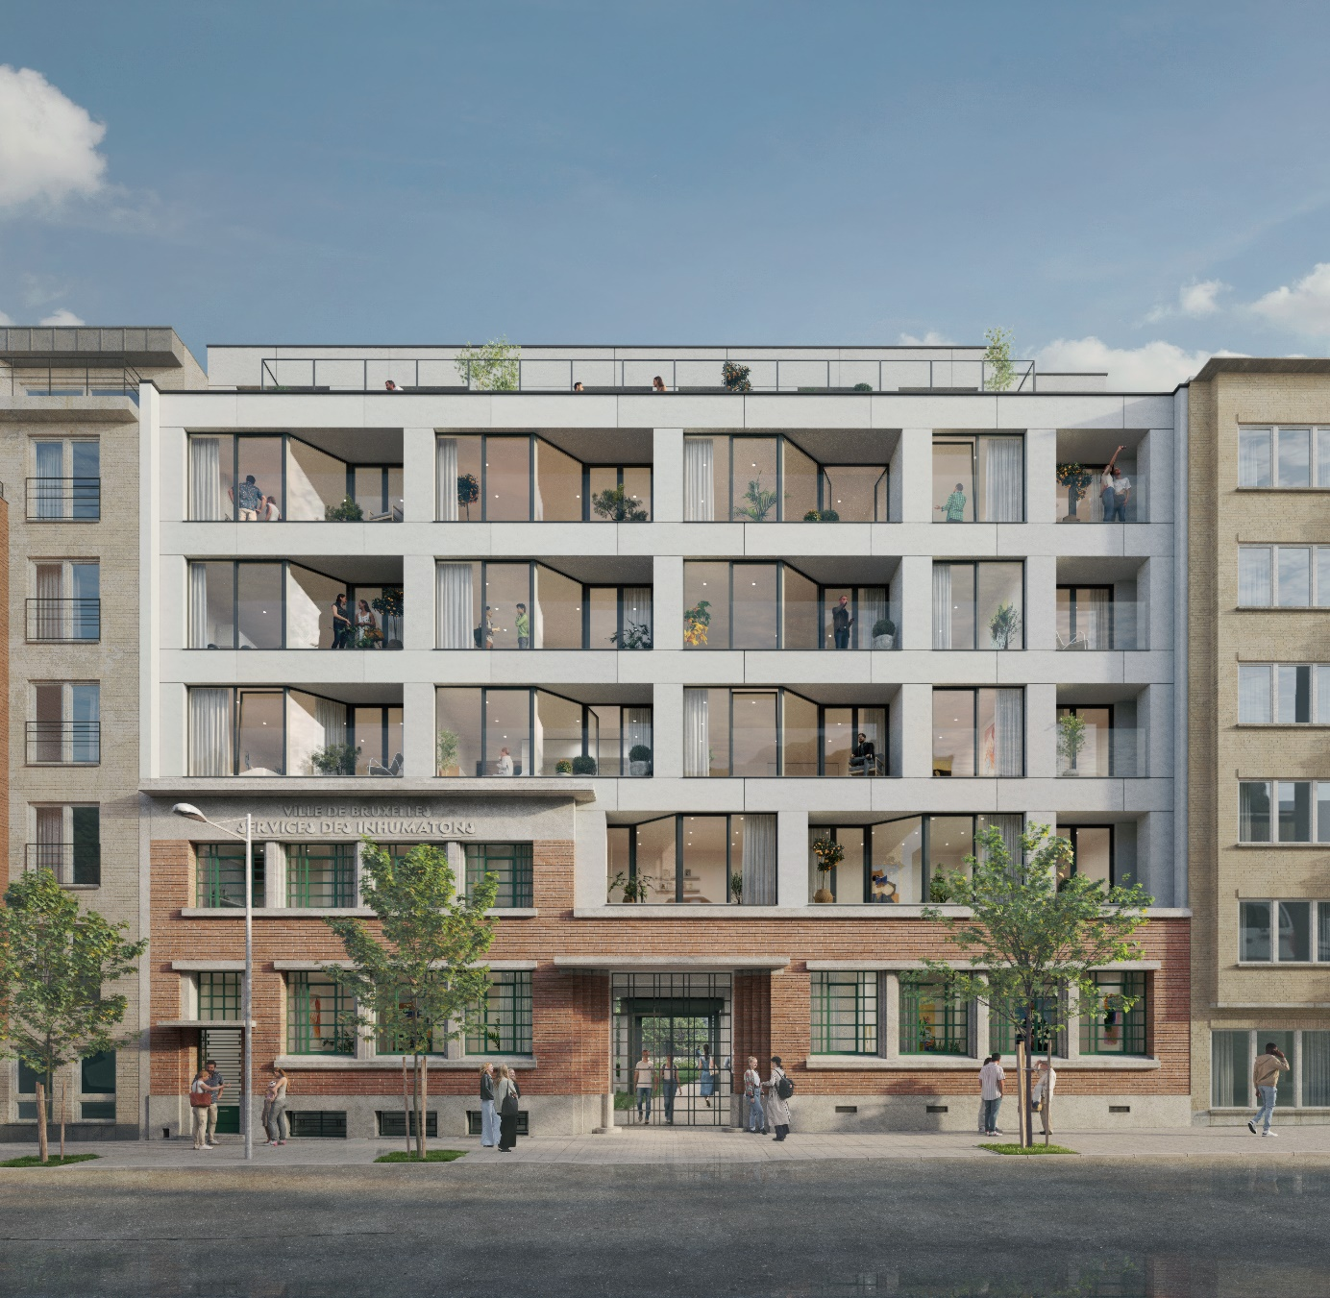

In Artico everything is close by!

Artico is situated near the lively centre of Evere: shops, cafés, restaurants. Schools, supermarkets and sports facilities are all close by.
Artico is also ideally located for motorists, commuters and cyclists: you can easily reach the Brussels periphery and there is an excellent connection with the E40, public transport and numerous cycle routes.
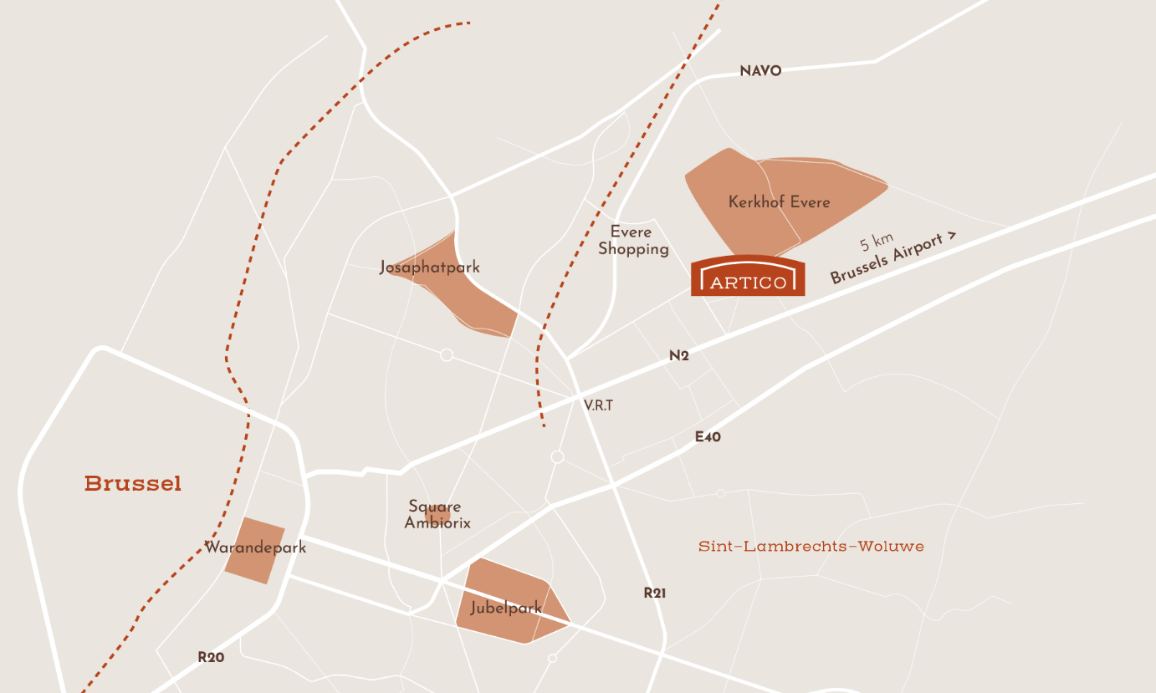
Artico is a place where it is pleasant to live: brand new and full of character, simple and timeless, dynamic and stylish. The architects made sure Evora’s design fits in perfectly with the individuality of the neighbourhood.

Something for everyone!
Artico consists of 21 spacious, newly built units, divided over 5 floors. Ground floor apartments with a terrace and private garden, smart studios, 1-, 2- and 3-bedroom apartments with large windows and a terrace, but also unique rooftop apartments with very large terraces on the top floor.

Description of the general construction works
ARTICO is built with durable, high-quality materials according to the rules of the art.

Structural work

Groundworks
The excavation work is carried out to the required depth to enable the smooth implementation of the foundations and sewers. Backfilling around foundations and underground structures are made according to the guidelines of the stability engineering office.

Foundations
All foundations are set on solid, sufficiently load-bearing ground to assure the stability of the structure. The exact type of foundation, its dimensions and the material properties are determined by the stability engineering office, which forms its conclusion on the results of the soil examination. The calculation of the building's load-bearing structure is carried out on the basis of the usage loads and the prevailing European and Belgian standards.

Load-bearing construction
Floor slabs, roof slabs, columns, beams and other possible building elements such as terraces, are made of a combination of steel and concrete. Load-bearing walls are also made of concrete. If necessary, steel and/or load-bearing masonry may be used if recommended by the stability engineering office.
The maximum load for the terraces is limited to 400 kg/m².
All construction elements are carried out according to the guidelines of the stability engineering office and comply with the relevant European and Belgian standards. The load-bearing construction is drawn in detail on the stability plans of the building. The indications of the load-bearing construction on the architectural and sales plans are therefore purely informative.

Walls
The walls in the new underground parking space, the new stair cores, the new storerooms are executed in visible concrete of masonry of concrete blocks. A watertight layer will be incorporated in the walls where necessary.
All walls between private and common parts will be de-duplicated with application of acoustic insulation to ensure acoustic comfort between apartments.
The interior walls will be constructed of plaster blocks; silicate blocks, concrete, plasterboards and/or cinder blocks.

Floors
The floorboard between the apartments is constructed as follows:
- Finishing of the floor according to the Purchaser's choice;
- A floating screed;
- Sound insulation membrane including insulation strips applied upwards along the walls;
- Pipes for underfloor heating;
- Insulation layer with embedded technical pipes;
- Load-bearing construction;
- (Spray) plaster on concrete and/or laminated plasterboard.
The exact and final construction is determined by the designer.
.

Façades
The facade cladding at the front of the apartments consists of
- Fibre cement cladding (new building) for +2, +3 en +4 in a light grey-tone. At level +5 a fibre cement cladding is also in a grey tone. The final colours are determined by the designer.
- The brickwork of the facade of the existing ground floor and first floor are cleaned and preserved.
The facade cladding at the rear of the apartments consists of
- A white-tone plaster for the levels ground floor, +1, +2, +3 and +4. The final colour and grain size of the plaster will be determined by the designer. On the ground floor a plinth in blue stone is provided.
- At t level +5, fibre cement cladding is provided in a deep grey shade. The final colours will be determined by the designer.
The roof edge will be made of aluminium, lacquered in black.

Roof structure
The non-technical roof (above level +5 and partially above level +4) is constructed as an extensive green roof:
- Eaves in aluminium;
- Sedum;
- Substrate;
- Drainage membrane;
- Root resistant waterproofing in 1 or more layers;
- Thermal insulation in accordance with the regulations of the specialised PEB office;
- Vapour barrier to prevent condensation;
- Load-bearing construction;
- (Spray) plaster on concrete and/or plasterboards.
The technical roof (in function of arrangement of outdoor units for the air-water heat pump) will have a gravel layer as finish..
The exact and final structure is determined by the designer.
The Purchaser receives a 10-year warranty on the waterproofness of all roofing.

Exterior carpentry

Windows and parapets
The exterior carpentry is fitted with double high-efficiency glazing with a U-value of 1,0 W/m²K. Taking into account the PEB calculation the windows of the 5th floor and the windows of studio 1.03 are fitted with triple high-efficiency glazing with a U-value of 0,71 W/m²K.
The exterior carpentry is made of thermal break aluminium profiles painted in a black tone. The profiles used are of high quality and guarantee water, air and sound resistance.
The windows are fixed, sliding, opening, etc., according to the indication on the plans. Opening windows are provided with a steel parapet, lacquered in a black tone, identical to the parapet provided for the terraces.
The window sills on the outside will be made of aluminium painted black. On a ground-floor terrace, a blue stone threshold will be provided at the height of the sliding door, as for the doorsteps on the ground floor. The reveals on the inside are plastered. The window sill on the inside is made of an impact-resistant material.

Hinges and locks
The site is enclosed by a gate assembly (open lattice). This gate will be equipped with an electronic lock and can be operated by remote control. The letterboxes and the entry panel for the intercom system will also be integrated into this gate. This gate can also be controlled from the internal unit of the intercom system for each apartment.
The external doors of the communal entrance halls of the building are equipped with a fixed door handle on the outside and a door handle on the inside. Furthermore, these exterior doors are equipped with an automatic door closer, a cylinder lock and a knob cylinder on the inside to allow evacuation at all times.
The underground car park is accessible via a car lift (open platform). The car lift is enclosed by a fence (height ± 1.50m) on a sliding rail. This fencing can be operated by remote control. The car lift is not equipped with an emergency battery, but will return to a safe level in case of power failure.

Balconies and terraces
The terraces will be made of concrete.
On the indoor terraces (front façade) and the terraces of the apartments at level +5 (roof terraces), tiles are placed on tile supports.
The exterior terraces on the rear façade will be made of grey architectural concrete. The concrete remains visible, both on the sides and on the bottom and top. No additional terrace finishing will be provided at these exterior terraces.
The ground floor terraces will have a wooden finish.
The choice of the finishing is standard for the entire building and is determined by the designer. A deviating choice by the Buyer is not possible.
All interior terraces have a glaze parapet. The exact details and shape are determined by the designer.

Individual garden
Each ground floor apartment has a terrace and an individual garden. The individual gardens are landscaped with grass and living hedges to separate the garden(s) from the neighbouring garden(s). The terraces are separated from each other by a wooden fence.
The garden of the ground floor apartments is partly located above the basement and therefore partly forms a roof garden.
For the maintenance of the individual garden, a garden faucet will be provided, connected to rainwater.

Thermal and acoustic insulation
The building's construction complies with the PEB standard on energy performance, which applies to the building permit. With the PEB standard, the government wants to encourage the realisation of energy-efficient and comfortable buildings. In a building with a low E-level, a considerable energy saving is realised, which is beneficial for the environment and the energy bill of the Purchaser.
The exact E-level per apartment may vary depending on the orientation, the floor, the layout of the facade, etc., and will be determined per entity (after construction) in a certificate based on an individual calculation by the specialised PEB-reporting agency. This certificate will be handed over to the Purchaser after the apartment has been handed to him.
Regarding the air and impact sound insulation, the acoustic standard for residential buildings applies between the residential units above and next to each other, whereby at least the Normal Acoustic Comfort according to the relevant tables is met.
The thermal insulation of the façades is carried out in mineral wool (or similar).
The apartment separating walls will be de-duplicated and fitted with mineral wool insulation or equivalent to ensure the required thermal and acoustic comfort.
Thermal insulation of the floors in contact with the basement is carried out in heraklith boards or equivalent (will be insulated at basement level).
The entire floor finish is separated from the structure by impact sound insulation, which is also raised vertically to plinth height. A 'floating floor' is thus obtained. Given the limited use, all stairs in the common parts are considered emergency stairs.
The thermal insulation of the apartment roofs will be in PIR (polyisocuanuurate) or equivalent..

Technical pipes

Technical shafts
The technical shafts contain all cables, ducts, supply and return lines to and from the housing units. Their location and dimensions are determined by the technical engineering office in function of the space required to mount these pipes and ducts efficiently.
The technical shafts are indicated schematically on the plans and are to be considered fixed elements. The dimensions of these shafts are purely informative and will be determined by the technical engineering office. The enlargement, reduction, deletion or relocation of existing shafts or the addition of extra shafts for technical construction reasons cannot give rise to an adjustment of the selling price.

Water supply and drainage
The water pipes start in the technical rooms, run through the common vertical technical duct and are embedded in the screed of the apartment. The wastewater pipes run horizontally over the screed of the apartment and then via vertical technical tubes and the underground floor to the sewer connection.

Recycling of rainwater
In the communal garden a rainwater reservoir in accordance with the applicable regulations is provided.
The rainwater from the technical roofs will be collected and recycled for flushing the toilets in the apartments and for the garden faucets of the ground-level apartments. The rainwater drains will be fitted with a leaf catchers.

Sewage system
The sewage system is constructed of pipes in PE, PVC and/or concrete according to the regulations in force and according to the designer's insight. The diameter of the pipes is adapted to the flow rate of the various rain and waste waters. The sewerage network will be equipped with the necessary inspection manholes, fitted with the required siphons and connected to the public network in accordance with the applicable municipal regulations.
In the underground storey, the sewerage network will be visibly suspended, so that a simple inspection remains possible at all times.

Fire safety
All devices, in particular fire doors, wall reels and powder extinguishers, are installed in accordance with the advice of the fire brigade accompanying the building permit and the applicable royal decrees. The necessary emergency lighting and signposting are provided in the stairwells, corridors and underground floors.
The apartments are equipped with autonomous smoke detectors. Any smoke is channelled away from the stairwell via the roof dome.

Utilities

Water en electricity
The individual water meters and electricity meters of the apartments will be installed in the common meter room on the underground floor.

Tele distribution, internet- and telephone connections
The contractor will lay the cables for the tele distribution, internet and telephone connections up to the apartments, pending the connection by the distribution company after the Purchaser has concluded a supply contract.

Connection of utilities
All connection, installation, commissioning, consumption and subscription costs of the utilities (water, electricity, telephone, TV distribution) are not included in the sales price and will therefore be at the expense of the Purchaser. The Purchaser will pay its share of the cost of the utilities on demand by the Vendor.
The Vendor will coordinate the connection of water, electricity, telephone and TV distribution. The Purchaser will conclude its own supply contract for electricity and water with an energy supplier in consultation with the Vendor. The Vendor will inform the Purchaser of the details required for the conclusion of these contracts. The Purchaser will provide the Vendor with a copy of this contract.
The contracts for the common utility connection as well as the subscriptions for the telephone connection in the elevators are concluded by the Vendor in the name and for the account of the co-owners' association.
.

finishing of the private areas
For each apartment, there is a photo file with an individual, detailed description for the choice of finishing materials and the corresponding budget. This description is part of the sales file and prevails the other stipulations.

Floors and skirting boards
The base price of each apartment includes the delivery and installation of the flooring with skirting boards as described below, if included in the individual detailed description of the photo file. Other materials, formats or installation may give rise to a customer charge. Floor and wall coverings should be chosen at Ri.Pa (Tile Trade Center)

Tiles
In all apartments, with the exception of the studios, In all apartments, with the exception of the studios, floor tiles will be provided in the bathroom(s), toilet, kitchen and storeroom(s) (if present in the apartment concerned), cf. the indication on the sales plan.
These are ceramic floor tiles with a format of 60 x 60 cm, not rectified.
The floor tiles are glued straight onto the screed and grouted with standard grey cement mortar.
The private market value, excluding VAT and installation, is €25/m².
For the studios, floor tiles are provided in the entire apartment. These are ceramic floor tiles in a 60 x 60 cm format, not rectified, glued straight onto the screed and grouted with standard grey cement mortar. The private market value, excluding VAT and installation, is €25/m².

Parquet
In the apartments, with the exception of the studios, semi-oak parquet with a toplayer of 3-4 mm is provided in the living room, hall and bedroom(s); cf. indication on the sales plan.
When installing parquet, you should take into account (especially in the winter period) a possible longer drying period of the screed in order to obtain the correct humidity level and to guarantee a good execution. If, as a result, the implementation period is exceeded, this may never be used to the Vendor's disadvantage and the Purchaser may not claim any compensation as a result.
The private market value, excluding VAT and including installation, amounts to €75/m².

Skirting boards
Skirting boards are provided in all rooms with floors, provided there are no wall tiles.
In the case of ceramic floor tiles, the matching skirting boards are made of the same ceramic tiles. In the case of a parquet floor, skirting boards are placed in MDF.
The private market value, excluding VAT and installation, is €8.5/rm for the ceramic skirting boards and €7/rm for the wooden skirting boards.

Walls and ceilings

Wall tiles
In each bath and shower room, tiles up to ceiling height are provided on the walls adjacent to the bath and/or shower (if present in the relevant apartment).
The wall tiles are 20 x 20 cm ceramic tiles, not rectified. The tiles are installed straight on with cement mortar joints. The tiles are installed on a damp-proof cloth.
The private market value, excluding VAT and installation, is €20/m².

Suspended ceilings
Suspended ceilings in plasterboard or equivalent will be provided where required for technical and/or aesthetic reasons (e.g., to conceal ventilation ducts, etc.).

Plaster
The walls and ceilings of the apartment will be covered 'ready for painting' with (spray) plaster or filmed (when using gypsum blocks, gypsum cardboard panels and silicate blocks), cf. TV 199 and 201 of Buildwise. The walls and ceilings will be finished by the Purchaser's painter in order to make painting or wallpapering possible, i.e., filling up irregularities, sanding down the underlay, applying a primer and painting in the colour of the Purchaser's choice. Aesthetic sealant around carpentry will be carried out by the Purchaser's painter.

Interior joinery and accessories

Entrance door apartment
The entrance door of each apartment consists of a flat door leaf and a door frame. Each entrance door, in combination with the door frame, is fire resistant, as imposed by the fire regulations in the building permit. The entrance door is provided with a spyglass, a lock with cylinder and a door fitting with multi-point locking.
The door leaf is painted on the common parts side. Painting the inside of the entrance door (private side) is not included.
Three keys are provided for the entrance doors.

Internal doors
The internal doors are standard apartment tube span doors with door handles in aluminium. Hinged doors are fitted with 3 hinges.
The direction of rotation is indicated on the plans. The internal doors are each fitted with an internal door lock. One key per internal door is provided.
The painting of the internal doors is not included.

Window sills
For windows that reach the ground, the floor covering continues on the inside up to the window. The reveals on the inside are plastered. Where windows are not floor-to-ceiling, the window sill should be made of an impact-resistant material.

Letterbox, videophone and door opener
One letterbox with lock per apartment is provided.. The letterbox assemblies are integrated in the portal in the façade of the building.
The apartments are provided with an videophone installation. This consist of an internal unit in the entrance hall or living room of the apartment and an external unit at the portal on the street side. Each apartment can operate the electric door lock at the portal by the internal unit.

Kitchen
In each apartment an equipped kitchen of Grando is provided. The size and arrangement of the kitchen is shown on the sales plan for information purposes only. The exact layout and personalised elaboration of the kitchen set-up will be discussed in the kitchen builder's showroom.
The following kitchen elements and appliances are provided and included in the purchase price of the apartment, if included in the individual detailed description of the apartment concerned. For illustrative purposes, the devices are also listed in the photo file:
- One column cabinet with base units and, if applicable (see plan), a kitchen island;
- Highly scratch-resistant worktop;
- Electrical appliances:
  - An integrated fridge with freezer compartment;
  - A combi-oven;
  - An integrated dishwasher;
  - A vitro ceramic hob with four cooking zones and touch controls;
  - A cooker hood of the recirculation type, fitted with a carbon filter.
- Sanitary appliances:
  - A sink with a single or one and a half bowl sink;
  - A single lever mixer tap.
The kitchen elements and appliances mentioned above are of the common brands AEG Bora, Blanco, or equivalent.
The private trade value of the kitchen, including appliances and installation, but excluding VAT, is:

- Apartment 01.01: 7.263,52 €
- Apartment 01.02/01.03/01.05: 6.332,70 €
- Apartment 01.04: 6.889,96 €
- Apartment 02.01/03.01/04.01: 10.477,61 €
- Apartment 02.02/03.02/04.02: 7.093,97 €
- Apartment 02.03/03.03/04.03: 6.637,46 €
- Apartment 02.04/03.04/04.04: 7.497,33 €
- Apartment 05.01: 10.520,11 €
- Apartment 05.02: 7.510,08 €

Bathroom and sanitary appliances
For the design of the bathrooms we collaborate with Facq. The lay-out of the sanitary appliances is shown on the sales plan for information purposes only.
The following bathroom elements and sanitary appliances are provided and included in the selling price of the apartment, provided they are included in the individual detailed description of the apartment concerned. For illustrative purposes the devices are also listed in the photo file:
- A washbasin cabinet consisting of a base cabinet with 1 or 2 washbasins and single lever mixer(s) for cold and hot water;
- A mirror with LED lighting;
- A bath in plastic and single lever mixer tap with shower head (in apartments with both a bathroom with a bathtub and a second bathroom with a shower);
- A shower tub with limited height. The shower is equipped with a thermostatic shower mixer tap with shower head on sliding bar. Depending on the arrangement of the bathroom and/or shower cubicle, the shower is also provided with a fixed shower panel and/or shower door;
- One or more wall-mounted toilets with built-in cistern, energy-saving button, white glazed porcelain with white seat and cover, frontal white operating plate with 2 buttons;
- A hand-washer in white ceramic and cold-water tap.
- A hand-washer in white ceramic and cold-water tap.
For the above-mentioned bathroom elements and sanitary appliances, the quality chosen is that of Villeroy&Boch and Duravit, among others, and Ideal Standard for the fittings.
The private market value of the sanitary appliances, excluding VAT and installation, amounts to:
- Apartment 01.01: 3.542,39 €
- Apartment 01.02: 2.777,40 €
- Apartment 01.03: 2.719,98 €
- Apartment 01.04: 2.449,59 €
- Apartment 01.05: 3.047,79 €
- Apartment 02.01/03.01/04.01: 4.861,15 €
- Apartment 02.02/03.02/04.02: 2.682,40 €
- Apartment 02.03/03.03/04.03: 2.715,58 €
- Apartment 02.04/03.04/04.04: 3.509,90 €
- Apartment 05.01: 5.111,58 €
- Apartment 05.02: 3.001,49 €

Electricity

Basic setup
The installation will be carried out in accordance with the European and Belgian stipulations in force, the general regulations and the regulations of the company providing the electricity distribution. The installation will be inspected by a recognised inspection body on the instructions of the Vendor.
The individual electricity meter is installed in the therefore foreseen communal meter room in the basement of the building.
The installation is earthed and equipped per apartment with a distribution board with automatic fuses and loss-of-current switches for the various circuits.
Pushbuttons and sockets are built into the walls and are provided in a standard colour and of a common brand. The necessary cables for the tele distribution, Internet and telephone connections are also provided.
The lighting points are provided on the ceiling or wall. The installation includes (in addition to any requirements under Article 3.4 and 4.5 described integrated lighting in the fixed kitchen and/or bathroom furniture), no light fittings in the private areas, with the exception of the terrace lighting. The choice for the terrace lighting is made by the designer. A different choice for the terrace lighting by the Purchaser is not possible. The lighting points in the private areas shall be delivered with a lamp fitting.
The following electrical installation is provided, so far present in the apartment:
- Private entrance hall:
  - 1 central light point (operated by 2 push buttons)
  - 1 doorbell button (on the outside of the entrance door)
  - 1 internal unit for the videophone (can also be installed in the living room)
If the entrance hall is also the night hall:
  - 1 single socket
  - With 2 or more bedrooms: 1 additional light point and 1 additional push button
- Living area:
  - 2 central light points (operated by 2 push buttons)
  - 3 single sockets
  - 1 double socket
  - 1 connection for telephone/data (UTP)
  - 1 connection for distribution (Coax)
  - 1 connection for the room thermostat
- Kitchen:
  - 1 central light point (operated by 1 push button)
  - 1 single socket above the worktop
  - 2 double sockets above the worktop
  - 1 socket for the oven
  - 1 socket for the fridge
  - 1 socket for the hob
  - 1 socket for the cooker hood
  - 1 socket for the dishwasher
- Technical storage room:
  - 1 light point above the door (operated by 1 push button)
  - 1 single socket
  - 1 double socket for the washing machine and tumble dryer
  - 1 power supply for the heating
  - 1 power supply for the ventilation unit
  - 1 electricity fuse box and data connection point (coax and UTP)
  - 1 double socket for the power supply of the data installation(s)
- Non-technical storage room (if applicable):
  - 1 central light point (operated by 1 push button)
  - 1 single socket
- Guest toilet(s):
  - 1 central light point (operated by 1 push button)
- Bath and shower room(s):
  - 1 central light point (operated by 1 push button)
  - 1 light point above the mirror (operated by 1 switch)
  - For a single washbasin: 1 single power point (decentralised)
  - For a double washbasin: 1 double socket (central)
- Bedroom(s) with double bed
  - 1 central light point (operated by 2 push buttons)
  - 2 single sockets
  - 1 double socket
  - 1 connection for telephone/data (UTP)
  - 1 connection for distribution (Coax)
- Bedroom(s) with single bed and desk(s):
  - 1 central light point (operated by 1 push button)
  - 2 single sockets
  - 1 double socket
- Night hall (not applicable if this is the same room as the entrance hall):
  - 1 central light point (operated by 2 push buttons)
  - 1 single socket
- Main terrace (not applicable to a possible second terrace)
  - 1 light point with light fitting (operated by 1 push button)
  - 1 single, watertight surface-mounted power point.

These electrical provisions will be carried out as indicated on the final implementation plan, which will be drawn up by the engineering office techniques. When drawing up the final implementation plan for the electrical installation, the Purchaser will be consulted and will be given the opportunity to have any personal preferences incorporated into this plan. Certain modifications or additions to the technical installation may result in an additional charge to the purchase price of the apartment and will result in a customer settlement.

PV-Panels
No PV-panels are planned.

Heating
The installation will be carried out in accordance with the applicable European and Belgian stipulations, the regulations of the utility companies and the general regulations. The installation will be designed and dimensioned by the engineering office. The installation will be inspected by an accredited inspection body on the instructions of the Vendor.
The apartments are heated by an individual installation with an air-water heating pump of which the internal unit is located in most apartments in the technical store room.
The heating system is also responsible for the production of domestic hot water.
The temperature control for each apartment is set centrally via a user-friendly wall thermostat in the living area of the apartment.
The heat emission in the apartment is done by means of floor heating. In the bathroom(s) a decorative radiator is also provided. The sizing of the heat emission elements is determined by the engineering office on the basis of a detailed heat loss calculation, taking into account the temperatures to be achieved in the relevant rooms as indicated below.
At an outside temperature of minus 8 degrees Celsius, the following temperatures are guaranteed:
- In the living room, the kitchen and any office: 22°C
- In the bedroom(s): 18°C
- In the bath and shower room(s): 24°C

Sanitary installation
The installation will be carried out in accordance with the current European and Belgian stipulations, the general regulations and the regulations of the water supply company. The installation will be designed and dimensioned by the engineering office. By order of the Vendor, the installation will be inspected by a recognised inspection body.
A main connection tap is placed at the individual water meter in the meter room on the underground floor. Each apartment has a stopcock and a non-return valve in the storage room.
The drainage pipes are made of PE or PVC, according to the design of the engineering office techniques, and can withstand high temperatures. The cold and hot water pipes are made of plastic.
In the storage room of the apartment there is a water connection and drain for the washing machine. The drying cabinet has to work with internal condensation and can also be connected to the drain of the washing machine.
For a detailed description of the sanitary appliances and the tap work, please refer to article 3.5 Bathroom and sanitary appliances

Ventilation
Each apartment will be equipped with an individual balance ventilation unit (type D). The ventilation unit will be placed in the storage room, entrance hall or bathroom of the apartment and is equipped with the necessary air filters. . This unit extracts the air from the wet areas (bath and shower room(s), toilet(s) and kitchen) via ventilation channels and blows in fresh air via wall or ceiling grilles into the living and sleeping areas of the apartment.
The position of the supply and exhaust points and their respective flow rates are determined by the engineering office in function of the size of the rooms to be ventilated. Precautions are taken to keep the noise of the fans and the noise of air movement to a minimum.
In the kitchen, a recirculating cooker hood with an air filtration module is provided so as not to disturb the balance ventilation. This technique is energy-saving because no warm air is discharged to the outside via the cooker hood.
The dryer cabinet must work with internal condensation. It is not allowed to connect dryer cabinets with air exhaust.

Underground car park (if applicable)
The finishing of the car parking spaces is similar to the finishing of the other spaces in the underground storey (polished concrete floor, visible brickwork and concrete structure), as described under article 4 Finishing of the common areas. The pitches will be marked out and numbered. For the disabled parking spaces, the design imposed within the framework of the accessibility standards will be respected.
The underground car park will be closed with an electric sliding gate which gives access to the car lift. In the event of a power cut, the gate can be unlocked manually.
Each underground car space will receive one remote control which operates the gate for the car lift. Additional remote controls are available as an option.

3.11 Above-ground car park (if applicable)
The 2 above-ground car parking spaces will be constructed in concrete clinkers. The parking spaces will be demarcated by means of lines or a contrasting material in the construction. For the disabled car parking spaces, the design imposed under accessibility standards will be respected.
Each above-ground car park is provided with 1 remote control, which operates the sliding gate for the car lift. Additional remote controls are available as an option.
Each above-ground car park will be equipped with a charging infrastructure (open system; 22kW).

3.12 Basement storerooms (if applicable)
The finishing of the storerooms is similar to the finishing level of the other rooms in the underground storey (polished concrete floor, visible brickwork and concrete structure), as described under Article 4 Finishing of the common areas. For the underground storerooms of the existing building the existing structure is renovated.
The interior door of the individual cellar storage room is a standard flat painting door and is hung on a wooden or metal door frame to be painted with 3 hinges.
The electrical equipment consists of a central light point operated by a motion detector.

Above-ground storerooms (if applicable)
The internal door of the individual basement storeroom is a standard flat door and is hung on a wooden or metal door frame to be painted with 3 hinges.
The electrical equipment consists of a central light point controlled by 1 switch.

Finishing of the common areas
The design of the common areas is done on the designer’s advice with sustainable and high-quality materials and is worked into a harmonious whole.

Floors and skirting boards
All common entrance halls from the ground floor up will have a stylish, hard floor finishing with appropriate skirting boards. The stairs in the new staircases with corresponding landings will be made of (prefabricated) concrete. The existing staircase (stair C) will be renovated..
In the underground car park a polished concrete floor plate will be provided.

Walls and ceilings

Plaster
The ceilings and walls of the communal entrance halls and lift shafts are (from the ground floor upwards) covered with (spray) plaster or filmed (when using gypsum blocks and silicate blocks). In the new common stairwells, the concrete of the ceilings and inner walls remains visible.
In the existing staircase (stairs C) the walls and ceilings are plastered.
No plastering works are foreseen at basement level.

Paintwork
In the new common entrance halls and the lift shafts (from the ground floor upwards), all ceilings, walls and internal doors (on the side of the common parts) will be completely finished and painted. In the common staircases and in the basement, the concrete of the ceilings and inner walls remains visible and will not be painted. The internal doors in the communal staircases, on the other hand, will be painted.
In the existing staircase (stairs C) all walls and ceilings will be painted.
All colours will be determined by the designer in consultation with the Vendor.
The paintworks may be postponed by the Vendor until approximately six months after the provisional handover of the common parts in order to minimise damage during the first Purchasers’ move. The delay in the painting works cannot affect the occupation of the building and therefore cannot postpone or prevent the provisional acceptance of private or common parts.

Internal doors
The internal doors are flat doors with door handles in aluminium. The internal doors are hung on a wooden or metal painted door frame with 3 hinges. They comply with fire safety standards.
The internal doors of the common parts are completely finished and painted. The doors in the underground floors will not be painted.

Electricity
The common parts are supplied by an electricity meter, which together with the fuse board is located in the common meter room on the underground floor. From there, all cables for the various lighting circuits and the communal and technical installations, such as lifts, fans, etc., start.
The installation will be carried out in accordance with the European and Belgian stipulations in force, the general regulations and the regulations of the company providing the electricity distribution. The installation will be inspected by a recognised inspection body on the instructions of the Vendor.
All common parts will be provided with light points including light fittings, at the discretion of the designer. The installation for the common parts includes::
- Custom light fitting in communal entrance halls, staircases, lift shafts, meter rooms, technical rooms and corridors;
- Entrance halls and entrance areas: one or more light points, operated by a motion detector;
- In the stairwells, at least one light point per floor, operated by motion detectors;
- All necessary emergency lighting;
- The outdoor unit of the videophone per entrance hall;
- 1 socket for maintenance per common hall.

Heating
No heating is foreseen in the common parts.

Lift installation
The mechanical lifts without machine room comply with the standards and safety regulations. The lift cage is solidly finished with corresponding lighting and automatic operation by means of push buttons. An emergency call system is provided in accordance with current legislation, allowing immediate contact with a central dispatching centre in the event of a breakdown.
The lift will only be put into use after approval by a recognised inspection body. The lift will only be made available to the Purchasers after provisional completion of the common parts.

Fire protection
All legal prescriptions for fire safety are followed, such as the installation of doors with fire resistance, wall reels and/or fire extinguishers, emergency lighting, smoke domes, pictograms, etc.
The execution will be carried out in accordance with the advice of the fire brigade and the rules and regulations in force and imposed at the time the building permit is granted.
It is the responsibility of the Purchaser(s) to maintain and preserve everything relating to fire safety.

Access Control
The site is closed by means of a steel gate at the street side. The external post of the intercom (with doorbells) is fitted into this. The car lift is enclosed by a fence (height ± 1.50m) on a sliding rail. This fence can be operated by remote control. The car lift is not equipped with an emergency battery, but will return to a safe level in the event of a power failure. One remote control is provided per car park as standard. Additional remote controls are available as an option.
Access to the technical rooms, private storage rooms and meter rooms is via a cylinder lock.

Bicycle park
The apartments have a communal bicycle parking on the ground floor of the building. The bicycle parking is accessible to all apartments via the common entrance hall.
The communal bicycle parking is equipped with galvanised steel bike racks, fixed to the ground or alternatively with bike hooks. This will also provide space for parking cargo bikes.

CHOIcES AND CHANGES
The Contractor will appoint a Customer Supervisor, who will guide the Purchaser in the choice and decision process for the finishing of the privative area.

Choice of finishing
The Purchaser has the possibility to choose the material in the apartment according to his/her wishes between the following elements at no extra cost:
- The colour of the floor tiles: see options in the detailed description of the photo file referred to in Article 3.1.Floors and skirting boards. For the apartment 00.01 the choice of floor finishing is limited, given the restoration conditions imposed in the planning permission;
- The colour of the external finish of the kitchen cabinets and kitchen worktops: see choices in the detailed description of the photo file referred to in article 3.4 Kitchen;
- The colour of the bathroom and shower furniture: see options in the showroom.
Samples of the colours available for this purpose can be viewed in the showroom of the suppliers of the materials.

Timetable of decisions
The Customer Supervisor will communicate to the Purchaser a time schedule with the decision periods within which the choices of the finishes must be made.
The Purchaser must enable the Vendor to carry out its commitment. It must therefore respond within the decision period set by the Vendor and specified in the Customer Supervisor's correspondence to any request from the Vendor in relation to the completion of the private plot purchased by it. When this decision period has expired and the Purchaser has not made his choices in time and confirmed them in writing, the private plot purchased by him will be finished in accordance with the provisions of these sale specifications and the sales plan and/or the private plot purchased by him shall be finished in a cost-efficient manner with the selection of materials and colours according to the Vendor’s preference. In any case, the Vendor cannot be held responsible for exceeding the execution period and the Purchaser cannot claim any compensation for late delivery of the sold plots. In this case, the Vendor also reserves the right to recover from the Purchaser the additional costs resulting from the failure to meet the decision deadline.

Changes at the request of the Purchaser
Changes that the Purchaser wishes to make to the finishings foreseen in these specifications or to the plans of the apartment, are only possible with the written agreement of the Vendor or Customer Supervisor. Alterations will only be carried out after a timely written agreement from the Purchaser regarding the price and any other consequences of these alterations.
Alterations involving changes to the building permit or changes to constructions, technical equipment, facades, roofs or common areas are not permitted. The Vendor can always refuse requests for changes that either have too great an impact, are submitted too late or are disruptive to the smooth running of the project.
Requests for changes may lead to a later delivery.

Additional works and reduction
The price of any changes at the Purchaser’s request is calculated according to the following principles:

Additional works
Should the Purchaser order materials and/or works for the completion of his apartment which exceed the value of the provisional sum, the Vendor may request an advance payment by order of forty per cent (40%) of the value of the additional works. The remaining amount of the additional works will be settled in two parts: fifty percent (50%) together with the instalment invoiced after the placement and/or processing of the relevant materials and the balance upon provisional acceptance. In addition, the execution period will also be extended automatically by at least one working day for each instalment of EUR 400, excluding VAT, for additional work. In function of specific delivery and execution deadlines, this execution period can be extended even further.
The finishing work and any modifications shall only be carried out after a prior, written agreement from the Purchaser regarding the cost price, the execution method and the extension of the execution period. In the absence of such an agreement, the Purchaser will be deemed to have waived the changes and the plot will be completed as described in these sales specifications. Verbal promises have no value as long as they are not confirmed in writing.

Reduction in work
All (sub)contractors or deliveries will be carried out by (sub)contractors or suppliers appointed by the Vendor. Only in very exceptional cases will the Vendor allow parts of the foreseen finishing not to be carried out (if, moreover, this is requested by the Purchaser early and no problems arise with the orders already placed, the execution or the site planning in general). However, the Vendor will always have the right to refuse and will deduct a maximum of seventy per cent (70%) of the indicated, private market value (of the last instalment). Minus works can only be removed from the order after written agreement between the Purchaser and the Vendor.

Changes by the Vendor
The plans for the building are drawn up by the designer and the engineering firm(s), who bear responsibility for their design. Like the Vendor, they may make any alterations to the plans and specifications which are necessary or useful for the execution of the works, in accordance with the rules of art, aesthetics and the requirements of the competent authorities, PROVIDED THAT the value and quality of the works are respected. Thus, they have the right, among other things, to change the plan and/or the method of executing the foundations if, for example, it turns out that the original plan is not feasible due to the nature of the subsoil or if it seems appropriate to do so. Such modifications may also be the result of economic necessities (the absence on the market of the planned materials, reduction in the quality of supplies, delivery deadlines incompatible with the progress of the works, etc.) or arise from the absence, shortcoming or failure of the appointed contractor.
Adjustments to the basic layout of the kitchen and bathroom(s) and to the furniture can only be made with the explicit and written agreement of the Vendor (appointed contact person).

Works performed by the Purchaser
The Purchaser will not be permitted to carry out works on the site himself or through third parties before the provisional completion of his private plot. The commencement of the work to be carried out by the Purchaser and/or a (sub)contractor appointed by him, will constitute approval and provisional acceptance of the condition found and will exclude any subsequent dispute.
The Purchaser, as the commissioner of his own work, is jointly and severally liable with this
(sub)contractor to the Vendor, the association of co-owners of the building and third parties for all consequences arising directly or indirectly from this intervention. The Purchaser is also obliged at all times to respect the legislation in force, in particular that on safety coordination, and will also reimburse all costs that could not or not sufficiently be recovered from the contractor(s) appointed by it due to insolvency, failure, inadequate insurance, etc.
The Vendor will not bear any responsibility for damage, theft or loss of the whole or any part of the deliveries or works carried out by the Purchaser or by the (sub)contractor(s) appointed by the Purchaser.
The attention of the Purchaser is drawn to the fact that the building is new and that therefore a slight general or partial settlement may occur, as well as a possible expansion, caused by temperature fluctuations, causing slight cracks to appear. Neither the Vendor, nor the designer, nor the engineering offices or the (sub)contractors can be held responsible for this. The Vendor is also not responsible for damage caused by premature painting and wallpapering by the Purchaser.

Administrative stipulations

General
The purpose of these specifications is to describe the construction and finishing of the apartments and the building. The architectural and technical plans are used as a reference for the dimensions of the apartments and the technical equipment. For the description of finishing materials, these specifications prevail the plans.
However carefully the designers and engineers have studied the existing situation, it cannot be ruled out that during the execution of the works, 'unknowns' or 'difficulties' may be discovered, resulting in a deviation from the execution plan and/or sales plan. In any case, a deviation will always be carried out according to the rules of the art AND without detracting from the concept or quality of the project.

Floor area and dimensions of the property
The net floor area is an indication of the habitable, usable area, the interior dimensions of which are shown on the sales plan, in accordance with the design as it appears at the time. These are the net measurements from inside wall to inside wall, which the purchaser has to take into account for the placement of his furniture and the like. In most cases, the total net floor area is not given, as this depends on the layout of the apartment (which can still change). If, for example, an additional internal wall is added or removed, this will affect the total net floor area.
When determining the net floor area, the area (in plan) of the common and private interior and exterior walls, interior doors, cavity walls with insulation, (technical) shafts, sides of a walled-in terrace, etc., of which you also become the owner as a purchaser, are not taken into account.

Gros (floor)area
The gross floor area is the total area that is built and of which you, as purchaser, become private owner and partly co-owner, whereby the common and private interior and exterior walls, cavity walls with insulation, (technical) shafts, skirting boards, sides of a walled terrace, etc. are added up. After all, a apartment is part of a whole and does not merely consist of habitable surface or net floor area. It is this surface area that is relevant to the sales agreement.
The gross area mentioned on the sales plan is roughly the area between the outside of the outer walls, the axis (half the thickness) of the common inner walls and the window surfaces measured on the outside of the wall. This method of calculation is common in turnkey projects. The method of measurement is illustrated on the attached measurement code of the professional organisation for the real estate sector( (BVS).
The sales plan already takes into account the optimisations made in relation to the licensed plan. Licensed plans are after all further optimised in order to arrive at the later execution plans.

General disclaimer
The dimensions and measurement figures stated on the plans and drawings or in the brief technical description are always plus/minus dimensions. Small differences that may be determined after finishing and on delivery are regarded as tolerances.
If, for example, 0.5 cm extra plastering were to be added during execution, these dimensions will no longer correspond exactly to the dimensions on the sales plan. In the agreement - as is also customary - a reservation is made in Article 2 'State of the property' for any inaccuracies in size or surface area, up to a maximum of 1/20th.

Price of the property
The price for a specific property is fixed and calculated mainly, but not exclusively, on the basis of the gross floor area. The price also takes into account the orientation, the location in relation to e.g. the lift, the floor, the finishing... and also the share of each property in the general and private common parts of which purchasers also become co-owners and which are listed in the applicable basic deed. This enumeration includes the foundations, the facades and the cladding, the common walls, the roof, the stairs, the lift, ... which also have to be built and are therefore included in the selling price.

STIPULATIONS
ARTICO is built according to the regulations in force on the date when the building permit is applied for. The structural work and the finishing are done in accordance with the rules of the art, and according to the following standards and codes of practice:
- The Belgian and European standards;
- The General Principles for Labour Protection;
- The technical information sheets of Buildwise;
- The General Regulations on Electrical Installations;
- The regulations of manufacturers and/or suppliers of the materials and components used.

Indications on plan and images
Furniture and cupboards shown on the plans, illustrations and 3D animations are only indicative to show the possibilities of furnishing this room.
The Contractor will provide a detailed plan of the kitchens. This plan prevails the description of the kitchen in these commercial specifications and over the sales plan.
All the illustrations in these specifications are purely informative.

Access to the site
The Purchaser is prohibited from entering the site without the Vendor’s written permission and in the presence of the Vendor's appointee and subject to compliance with the safety regulations. In any event, access to the site will be at the Purchaser’s own risk and the Purchaser will not have any recourse against the Vendor for accidents to himself, his family or his agents.
Site visits are not organised on a systematic basis.

Fees designer and engineering bureaus
The fees of the designer, the stability engineering and technology studies, the safety coordinator and the PEB and ventilation reporter, appointed by the Vendor, are included in the selling price.
If the Purchaser is assisted or advised by an architect, an engineer, an expert or the like, all costs related to this will be at the expense of the Purchaser.

Remarks
The selling price of the apartment does not include:
- The lighting fixtures, except in the common areas and on the private terraces and balconies;
- Curtains, curtain boxes and rods;
- Furniture;
- The preparation and painting of private areas such as walls, ceilings, carpentry...
- Any changes at the Purchaser’s request;
- The taxes and duties starting from the execution of the authentic deed;
- The subscription costs or the rent for tele distribution, internet and telephone from the provisional delivery;
- The consumption of water and electricity as of the provisional delivery;
- The fire insurance as of the provisional acceptance;
- The maintenance of the common parts as from the provisional acceptance

Insurances and transfer of risks
The Vendor will take out the first insurance policy for sufficient amounts to cover the risks of fire, explosion, lightning strike, etc. This policy will be taken over by the co-owners' association during the construction phase for the contractual period still to run and the co-owners' association will pay the premiums for it as soon as the said policy is taken out.
The transfer of risks in accordance with Articles 1788 and 1789 of the Civil Code will take place at the time of provisional acceptance of the common parts of the building or the sub-building, or, as the case may be, at the time of provisional acceptance of a private area (or areas) in the buildings if, for any reason, this acceptance takes place earlier.

Conclusion
In the event of contradictions between the sales documents, the following order of precedence shall apply:
1. Articles of association (if applicable)
2. Purchase deed
3. Sales agreement
4. Sales specifications
5. Plans
Drawn up at Ghent on . . . . . . . . . . in two copies, each party declaring to have received his own.
The Purchaser hereby declares that he has taken full notices of what is stated in these sales specifications. The Purchaser and the Vendor also declare that no other agreements have been made than those contained in the sales agreement and in the sales specifications.

For the Purchaser(s)

_________________________ _________________________
For the Vendor(s)

_________________________ _________________________

